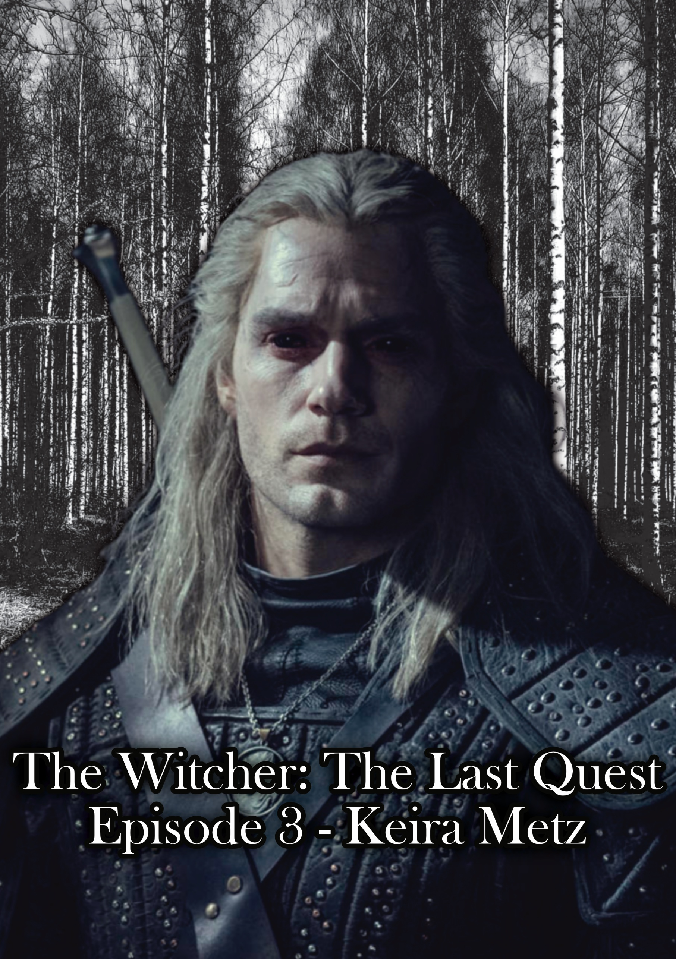

Episode 3 – Keira Metz

We fade in with Geralt walking along the road with Roach at night, the moon being the only light. They come to a small water pond and Roach starts drinking. Geralt leans against the little dirt wall and pulls out his water pouch and drinks. After putting it away he says to Roach:

“Which one do you think she’ll be?”

Roach stops drinking and stops as if he’s thinking and breathes out heavily and goes back to drinking.

Geralt mutters to himself:

“No one comes to Velen willingly…”

Roach stops drinking and starts to walk. Geralt starts to walk with him as he says:

“Though you never know… with Novigrad being so close.”

They arrive at a small stone bridge that’s been destroyed. They walk off the trail and down through the water, the soft splashes as they walk through the stream disturb a resting drowner, who’s eyes appear over the water after they leave and it watches them walk up the hill. As they start back on the trail Geralt says:

“This will be interesting either way.”

Smash cut to:

***TITLE SCREEN:  
THE WITCHER – Episode 03: Keira Metz***

We cut back to Geralt and Roach walking along the pathway as the sun starts to rise a head of them a pack of rotfiends feed on a horse and man who was driving a carriage with said horse that’s now the on the ground torn apart. Roach stops and Geralt takes his silver sword out and walks towards them saying:

“Rotfiends…”

They notice him, screech and start sprinting at him, he slashes the closest in half and jumps backward coving his face as its body explodes covering him in guts, the explosion hits the other two who explode in the process and cover Geralt even more. He sighs and says:

“I hate rotfiends.”

He swings his arm down and a piece of an intestine falls on to the ground splashing in a puddle. Roach walks calmly past the carnage, stepping over the remains of the Rotfiends. He continues to walk with roach, and they turn a corner to see a group of villagers at the door of a house in the distance asking Keira what she’s doing.

Man 1: “You’re a witch!”

Woman 1: “The eternal fire shall cleanse you all!”

Keira: “Now now, I’m not a witch I just professional, not like that pathetic Pellar.”

Man 2: “My uncle said you was a witch!”

Keira sighs as she notices Geralt approaching and says: “The Baron has allowed my presence here, take it up with him.”

She closes the door, and the villagers walk off annoyed. Geralt watches as they pass almost not noticing the smell… almost.  
  
He starts to walk up to the door of her hut and says:

“Roach… don’t die, ok?”

Roach says nothing. He turns to see Roach eating her flowers and says:

“Good enough.”

He knocks on the door. There’s no response.

He knocks on the door again saying:

“Keira, we have to talk.”

There’s no response.

He stands back and uses Aard, blowing the door open and entering the hutt. He looks around to see she’s nowhere to be seen. He walks slowly through the hutt, analyzing the books open on the table with herbs and animal parts in jars. He walks to the back room; a yellow glowing portal is open pulsing through space and time, it’s a rip in the universe, sharp edges, torn open, we can see an underground lair through it. He sighs and says:

“I hate shortcuts…”

He grips his sword and walks through. The world changing to an underground layer as he does so, a gazebo elevated with staircases running on either side to it is on his right. Plants grow through and are almost communicating with each other, growing longer and longer and moving through the walls of the cave. He starts to walk up one of the staircases as plants spray him with essential oils. The first time he’s mad but doesn’t react, the second he slaps the plant, and the third he cuts the flower off right as he arrives at the top. Keira sits nude in a hot tub and says:

“Geralt… what a surprise!”

Geralt sighs and says:

“Keira, we have a lot to discuss.”

Keira laughs, leans on the edge of the hot tub and says:

“Oh, that can wait.”

She smiles and spins her finger in the air. Geralt rolls his eyes and turns around as she gets out of the hot tub, and a flash of light is seen on Geralt’s back. He turns around and she’s dressed and walks up to a table with a powder ground up in a bowl. She takes a small amount and puts it on her neck and says:

“You smell terrible.”

Geralt sighs and says:

“Rotfiends.”

Keira smiles and says:

“Naturally.”

Geralt says:

“I’m here on business.”

Keira responds:

“But business can be so boring…”

Vines wrap around his shoulders and drag him above and drop him into the pool of water and she walks over and leans on the edge saying:

“And you really need a bath.”

The plants twist into a chair behind her and she sits:

“Tell me why you’re here.”

Geralt starts washing his clothes and himself and says:

“2 reasons, but the first is the Baron’s wife Anna.”

Keira says:

“An unfortunate tragedy, but not completely unexpected.”

Geralt pauses and says:

“So, you didn’t help her escape?”

Keira says:

“Me? Why would I have?”

Geralt says:

“The pellar told me he sent her to the witch.”

Keira rolls her eyes and says:

“That fool is mad.”

Geralt’s eyes squint slightly and he says:

“If not you then who?”

Keira thinks for a second and says:

“It can’t be… he wouldn’t.”

Geralt says:

“Keira… who?”

Keira says intercut with Geralt washing:

“There’s a legend, an ancient one. 3 witches living in the swamp, in crookback bog.”

Geralt says:

“3 witches? As in from Aretuza?”

Keira laughs and says:

“No, these are more ancient. Far more dangerous.”

Geralt says:

“From where I sit, you are.”

She laughs and says:

“I thought you were here on Business.”

Geralt smiles subtly and says:

“How do I get to them?”

Keira says:

“You’re not hearing me Geralt, if she met them, she’s dead already.”

Geralt takes a deep breath and says:

“Fuck.”

As we cut to him dressed and Keira walking back up the stairs as she says:

“You said you had 2 pieces of business.”

Geralt watches as she enters and says:

“Ciri. She passed through here.”

She freezes on the stairs but remains composed and says:

“Cirilla was here? In Velen?”

Geralt is playing with the buttons of his shirt, and she pauses watching this and says:

“I could just conjure you new clothes it would’ve been faster.”

Geralt says:

“I prefer real, tangible things.”

She smiles and says:

“You like a little rough?”

Geralt just looks at her, and she starts laughing, she composes herself and then says:

“Sorry. You were saying, Cirilla.”

Geralt says:

“I tracked her and yen here and haven’t been able to locate a trace on either of them.”

Keira says (tucking a hair behind her ear and then crossing her arms lightly):

“You’re still looking for yen?”

Geralt pauses and says:

“I need to make sure Ciri is safe, and Emhyr and Yen are the only way that happens.”

Keira says, a little dismissively:

“Practical. A while ago there was an elven mage in the area, he asked about finding an Ashen Haired woman.”

Geralt says:

“You believe this was Ciri?”

She says:

“At the time I wouldn’t have, now? It’s very possible.”

Geralt says:

“And he had some sort of way of contacting you I suppose?”

She says:

“No, but he did give me the location of his hideout. Mages are sticking together more now.”

Geralt pauses and says:

“You were aid to King Foltest of Temeria correct?

She says:

“They believe we tried to assassinate him… and now they burn us at the stake in Redania.”

Geralt looks around and says:

“Hence why you’re in Velen…”

She smiles and says:

“Well look at you putting it all together yourself.”

He rolls his eyes and says:

“Come on, let’s go find the elven mage.”

They leave through a portal to a set of elven ruins, Geralt picks up a torch on a wall and lights it using Igni. The cave is cold, water drips from stalactites, and through the stone bricks, the darkness of the cave stretches to miles through layers and layers of tunnels, they can hear bone cracking and screeching noises in the distance. Geralt whispers:

“Are you sure this mage is still alive?”

She says:

“Of course he’s alive, he’s a mage.”

Geralt says:

“You’re a mage and I could kill you right here.”

She turns around and lights a flame on her finger, raises an eyebrow and says:

“I’d like to see you try.”

Geralt tries not to smile but a slight smile leaks through. He says:

“Come on.”

They walk through the tunnels, Keira glances over at Geralt as they walk through the echoing silent desolation that is the ruins. She says:

“You know… if I had known it was Ciri I would’ve helped.”

Geralt stops and for a second doesn’t respond and then says:

“I know Keira, you don’t need to defend yourself.”

She says:

“I jus- Well. I don’t need to justify it, but I wanted to say it.”

Geralt says:

“You feel guilty for not noticing sooner, so you’re trying to feel better about it.”

She pauses for a second and says:

“I’m sorry…”

Geralt smiles as he starts to walk again and says:

“There are thousands of people with ashen hair.”

She smiles as they continue to walk down a tunnel until they come to a portal. Geralt puts his hand out and says:

“Shall we?”

She grabs his hand, and they enter arriving at a different part of the ruins. They look around, chalk symbols are drawn on the walls, a bird, an octopus, and others. An image of the mage appears from a pole and he speaks:

“I’ve been waiting for you, sorry for the security precautions, but you understand. State of the continent.”

The transmission ends and Geralt looks around as Keira says:

“That was his helpful tip??!”

Geralt says:

“What kind of tip were you expecting?”

She smiles and chuckles in a kind of shock and says:

“I think that’s the first joke I’ve ever heard you try to tell.”

Geralt pushes a brick into the wall with a bird on it, and a portal appears. Keira asks:

“What’s the chances this kills us?”

Geralt sighs and says:

“60/40?”

She says:

“Well at least if I die, I’ll die with you.”

Geralt says:

“If I die, at least it’ll be fast?”

She smiles and says:

“A very *you* thing to say.”

She grabs his hand again and they teleport to a new puzzle room.

They enter the puzzle room, it’s a circular room with a single doorway cut into the rock, there’s ancient Elven text on the walls, below the text a set of rocks pulled out slightly with different symbols on them an eel, an octopus, a squid, and a shrimp, broken in some parts, Keira says:

“I have arms but no hands…”

Geralt says:

“I swim with no fins”

Keira says:

“What are we thinking?”

Geralt says:

“I hate mages…”

She raises an eyebrow saying:

“Present company excluded of course…”

He smiles and says:

“Of course.”

Geralt pushes the octopus, and a massive locking sound can be heard behind the wall, a fiery hiss flicks around the circular room to the portal cut out and reality rips apart revealing it, a slash in space and time, they walk over to the portal as this is happening. Keira says:

“It could be a trap…”

Geralt pauses and says:

“It makes the most sense.”

Keira says:

“Well… we-“

Geralt jumps through the portal and Keira says as she follows, looking down at the final word:

“Great. We’re dead…”

As she enters the new room, she turns to Geralt without looking around as she says:

“You know we could’ve talked about it instead of you just jumping in immediately.”

Geralt unsheathes his sword looking straight on ignoring her, she turns to see 3 Wild Hunt mages and a soldier, the soldier steps forward with his battle axe.

The three mages teleport away, and Keira says:

“Shit…”

They move into the major stone cavern; the battle axe wielding soldier starts moving towards them. Keira says:

“So… I support and you fight first?”

Geralt sighs and says:

“How mage like of you.”

She levitates stones in the air using magic and throws them at the soldier distracting him, the soldier swings at her, she blocks it with a conjured shield but gets thrown back against a wall. Geralt swings at the soldier, his blade bouncing off the armor and quickly backs up as the soldier’s attention switches to him. He shouts:

“We need to break the armor!”

Keira says:

“I can see that; I have 2 working eyes!”

She throws a large rock at the soldier’s head, his helmet smashes, and rips open slightly and she says:

“Do you have good aim?”

Geralt stops mid fight and says:

“Is that *meant* to be funny?”

She smiles and says:

“Just kill him…”

Geralt slashes the helmet, the sword gets stuck in his head, and Geralt walks back as the soldier swings, he dodges the axe and rips the sword out. The soldier walks for a couple of steps as blood gushes from his helmet and then he crashes on to the ground. Keira says:

“Wild Hunt…”

Geralt cleans his blade then sheaths it saying:

“Still after Ciri…”

Geralt kneels to examine the body, and Keira walks off to a small room in the back. We focus on Geralt as he takes a small pouch off the soldier and opens it. He pulls out a couple of white hairs, the light glinting off them, he sighs and drops them saying:

“Where are you…”

Keira shouts from the backroom:

“Geralt! I found something!”

He stands and joins her in the backroom, there are books torn apart, the whole place tossed and searched. Geralt says:

“A bedroom…”

Keira says:

“Oh, be quiet, look.”

She’s pointing to words in an open book left behind a diary and says:

“It seems he’s been researching the elder blood, left in a hurry.”

Geralt takes a deep breath and says:

“There must be a faster way to leave…”

Geralt walks out of the door examining the cave. The world goes black and white and red bleeds through the environment, a ghostly red figure and be seen running through Geralt and drops a piece of paper, the paper is no longer there. He runs towards a stone wall and holds a glass mirror to it and says an enchantment, then runs through the stone wall. The world fades back to normal and Geralt says point at the wall:

“Illusionary wall.”

Keira walks over to it with Geralt, while she says:

“Such basic magic for this kind of mage… I’m almost disappointed.”

She holds up a similar looking but different mirror and says an enchantment, the stone walls disappear and they walk through it, up a cave entrance and out to the water. Roach is standing there while eating grass. He looks over to them and then back to eating grass. Keira says:

“How?”

Geralt says:

“I’ve learnt not to question it.”

She laughs and there’s a silence. She says:

“It was fun… seeing you again.”

Geralt smiles and says:

“It was.”

She smiles and says:

“If you’re sticking around for a while…”

Geralt says:

“I’ll be going to crookback bog…”

Keira’s eyes light up and she says:

“I’d love to… for magical curiosity. Research.”

Geralt raises an eyebrow as they walk over to roach and says:

“Then I’ll see you in the Baron’s keep?”

She says:

“Tomorrow morning, I’ll be there.”

He jumps on Roach, and she holds to reins and he says:

“Sunrise.”

She smiles and says:

“By the tavern.”

He smiles and says:

“I’ll see you.”

Keira watches as they ride off, Geralt raises his hand, as if to say goodbye but doesn’t turn. She waves back hesitantly.

We fade to different scenes of Geralt riding Roach through the woods to “Che Vuole Questa Musica Stassera by Armando Trovajoli” The song and screen fades to them arriving back to the Baron’s hold and seeing a burning fire engulfing the stables. The Baron shirtless in the courtyard shouting at the fire:

Baron: “WHY WOULD YOU RUN?!”

Baron: “I gave you fucking… everything…”

He falls to his knees. Geralt gets off roach and walks over to him, and the Baron says:

“And you! Mutant shit judging me!”

Geralt stops moving toward him and watches him quietly as he laughs in disbelief and says:

“What? You think you’re better than me?!”

He hits his chest and shouts:

“This hell hole would be anarchy without me!”

We see Geralt’s jaw tense and teeth knash slightly as the Baron continues:

“These people rely on me, to keep order, peace!”

Geralt pauses for a second says softly:

“Fear is power for the weak.”

The Baron swings at him, sloppily missing and stumbling on to the ground. He stands up as Geralt says:

“I’ve killed monsters less evil than you.”

The Baron regains his footing then shouts:

“Mutant son of a bitch! What would you know?!”

Geralt dodges the punch the baron throws and punches him in the liver, the baron falls to the ground and throws up. Geralt looks down on him and says:

“You could change…”

Geralt kneels and grabs his hand and says:

“But then again, what does a Mutant know… about being Human.”

He cuts off his pinky finger, and the baron screams and holds his hand. Geralt stands back up as he says:

“Everything has its price.”

The Baron starts laughing as he falls back against a small stone wall around a tree in the center of the courtyard. The laugh morphs into crying as he looks at his hands shaking. Geralt sits beside him as he slowly weeps. The camera shows them from the front as On Melancholy Hill by Gorillaz starts to fade in (0:00 – 0:19), the Baron looking down to his hands still, he says shakily, sadly, lightly:

“What have I become?”

Geralt looks at him and says:

“A Monster.”

The song cuts to silence Geralt says:

“You just see it now.”

And we smash cut to credits with the song coming in on the chorus (0:40 – Rest).

*Author’s Note:*

*The characters and world of The Witcher belong to Andrzej Sapkowski and CD Projekt Red. This script, the dialogue, story flow, and narrative choices, or anything that is my original work is protected under Australian copyright law (registration pending). It is not intended for commercial use. Any use of this material without permission is prohibited, though reaction videos, breakdowns, and discussions are welcome and permitted in the spirit of collaboration. Additionally, artwork based on this is allowed, however I cannot guarantee, authorize or otherwise state that the shareholders will feel the same.*

END OF EPISODE